**DESIGN PRINCIPLES & PATTERNS**

**Exercise 1: Implementing the Singleton Pattern**

**File: Logger.java**

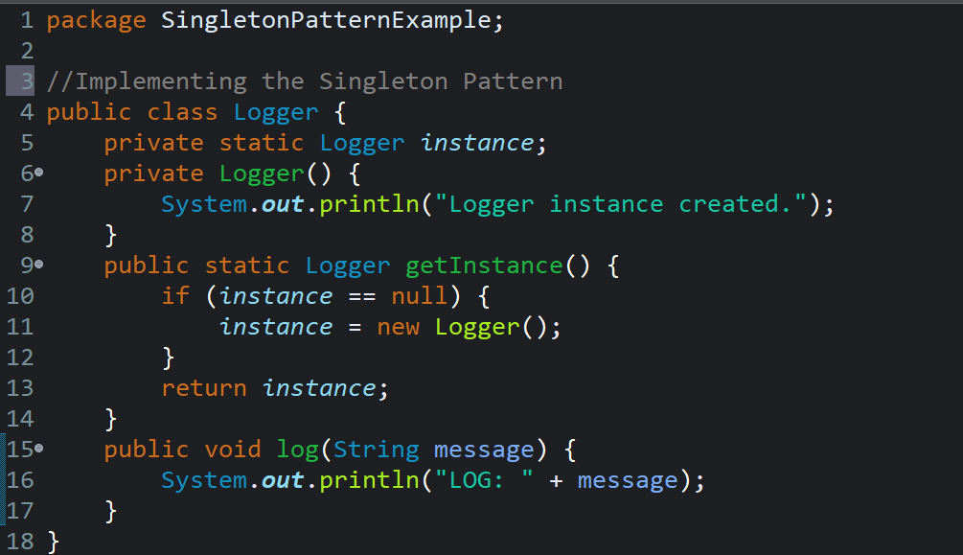

**File: Test.java**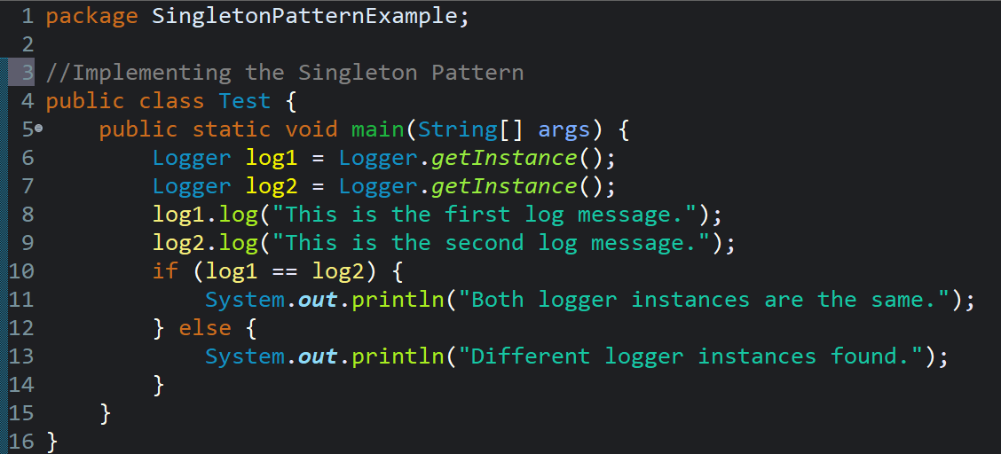

**Output:**

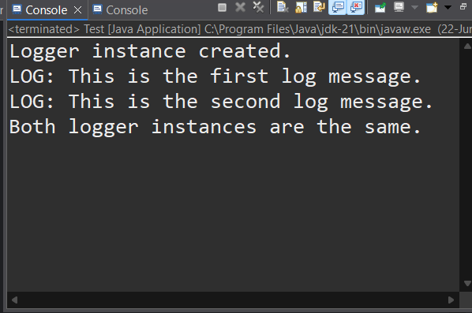

**Exercise 2: Implementing the Factory Method Pattern**

**File: Document.java**

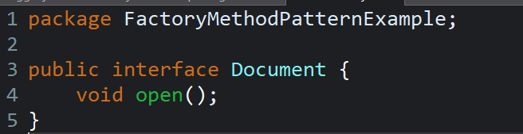

**File: WordDocument.java**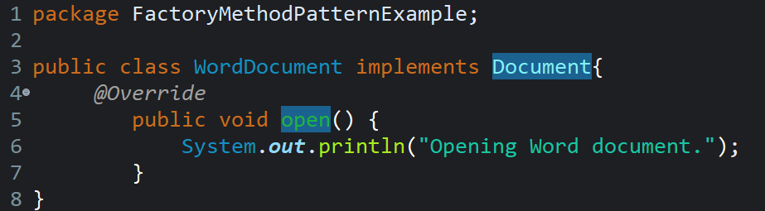

**File: PdfDocument.java**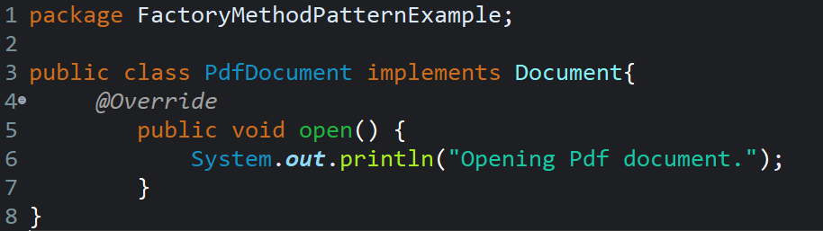

**File: ExcelDocument.java**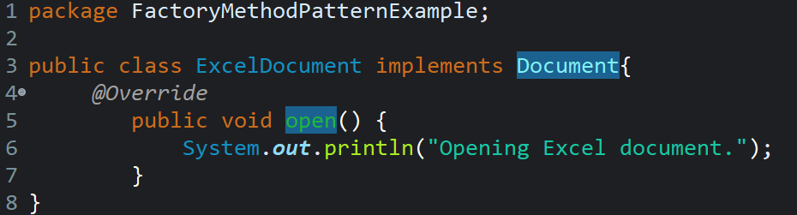

**File: DocumentFactory.java**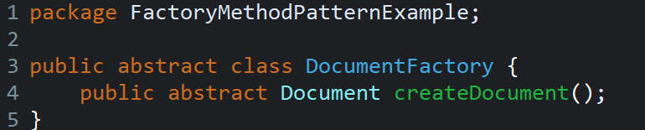

**File: WordDocumentFactory.java**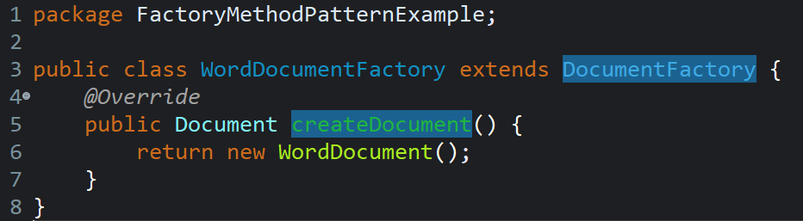

**File: PdfDocumentFactory.java**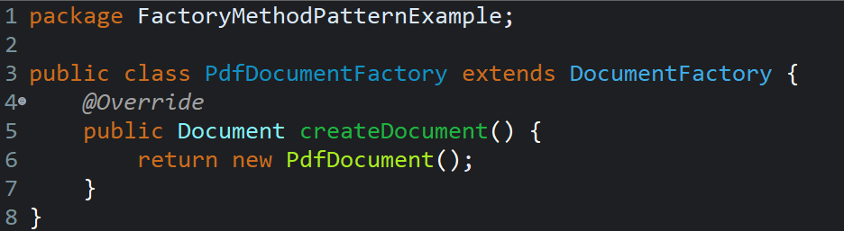

**File: ExcelDocumentFactory.java**

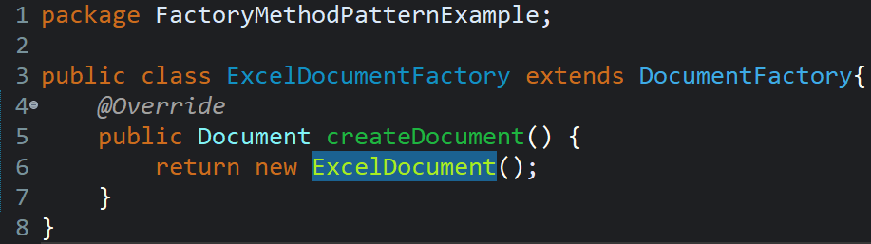

**File: Main.java**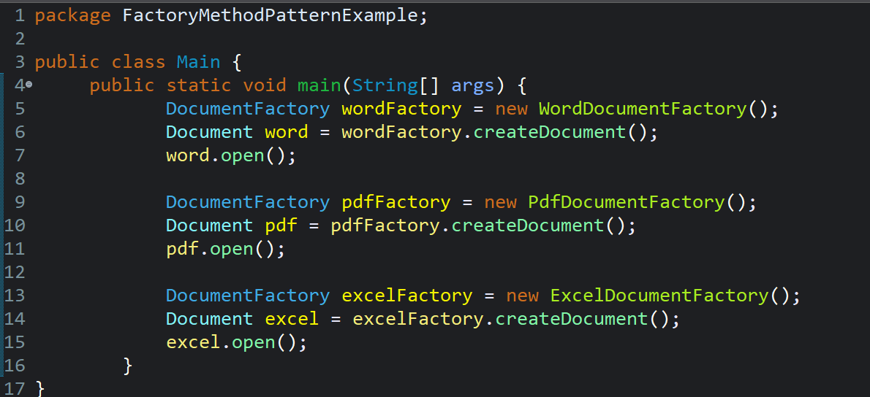

**Output:**

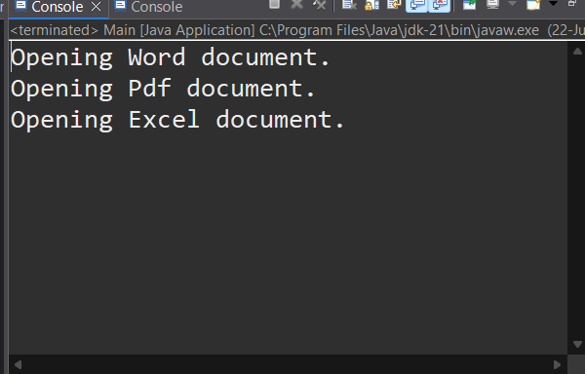

**DATA STRUCTURES AND ALGORITHMS**

**Exercise 2: E-commerce Platform Search Function**

**File: Product.java**

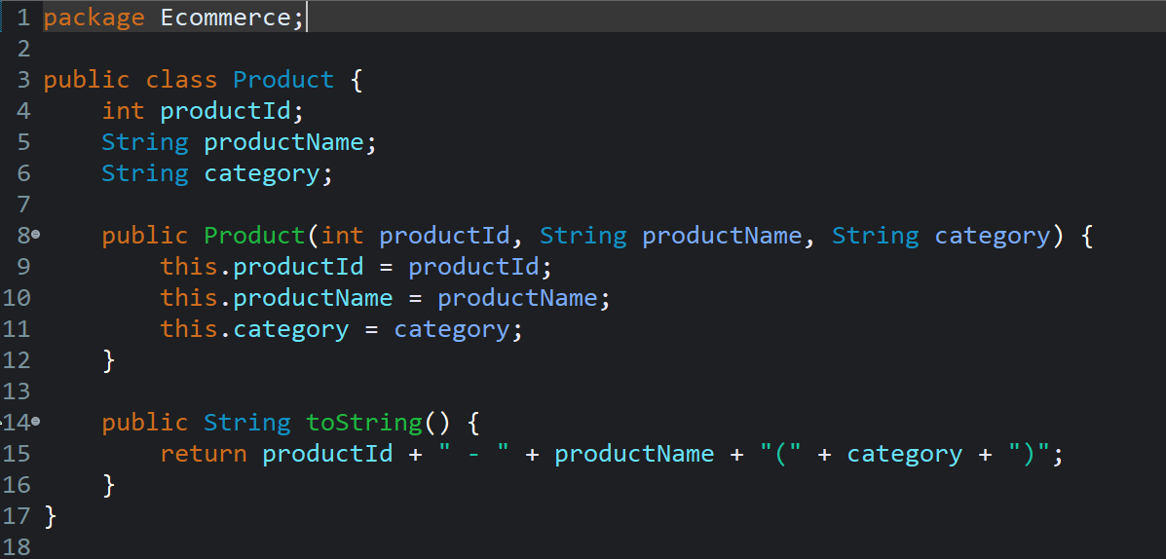

**File: SearchDemo.java**

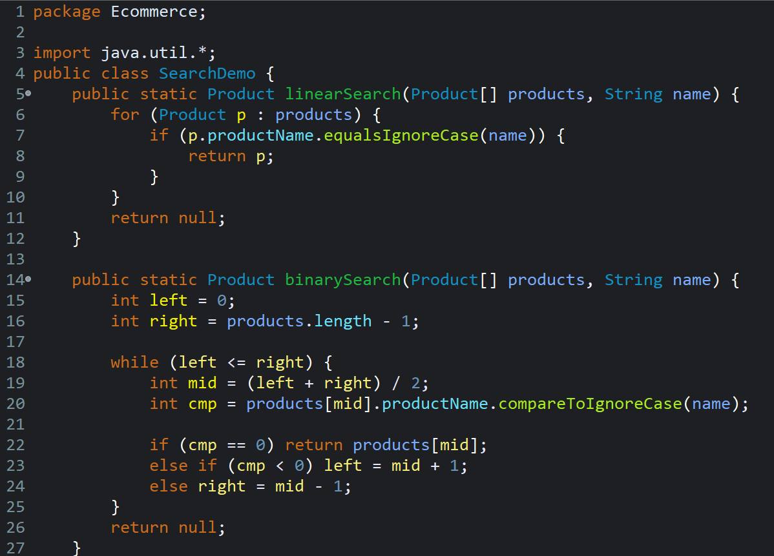

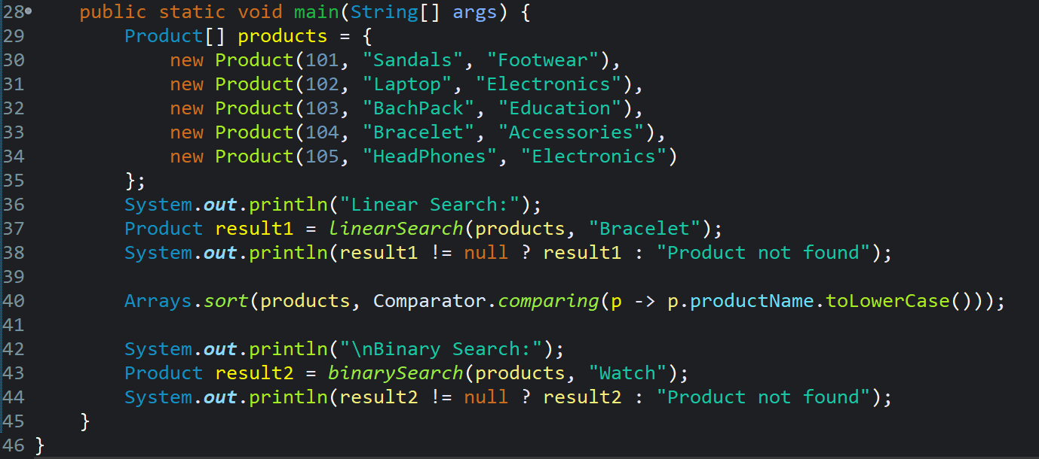

**Output:**

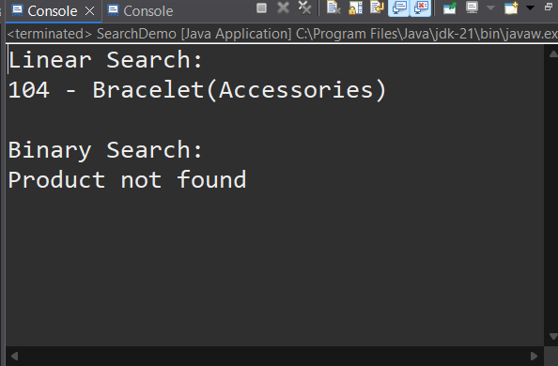

**Exercise 7: Financial Forecasting**

**File: FinancialForecast.java**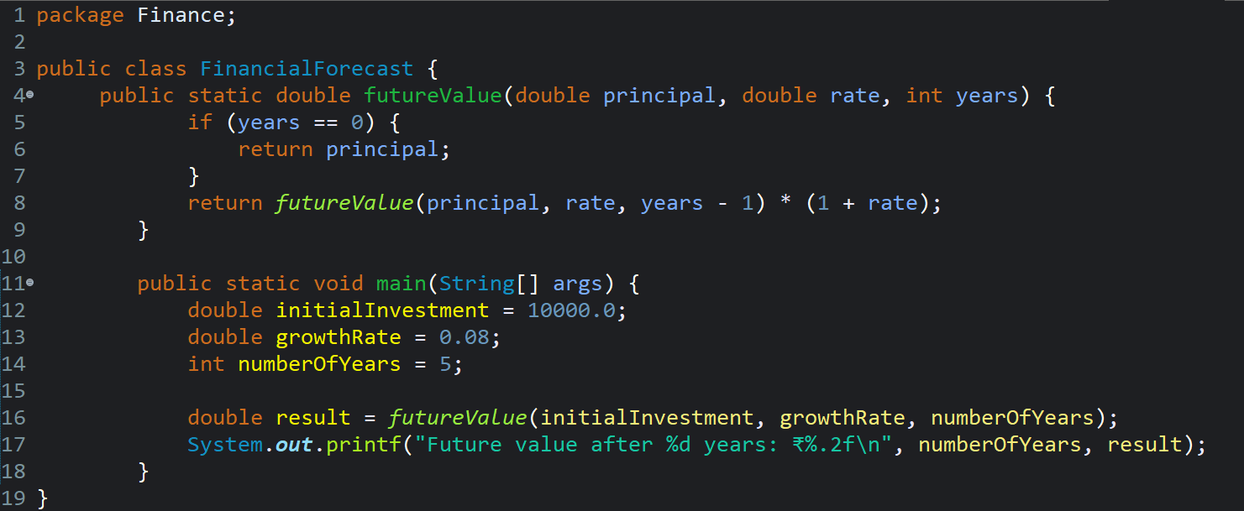

**Output:**

